*Data*

Data was obtained from the Human Connectome Project Young Adult 1200-subjects release. After removing participants with missing data points, a total of 1,082 participants remained.

*Measures*

The analysis made use of eight items from seven different measures (two items from one measure). Broadly speaking, the measures relate to executive function. Unless otherwise noted, the items represent an overall score for the test.

*Flanker Inhibitory Control and Attention*: Participant is shown a set of stimuli (arrows), one of which is the focus stimulus (ex. the middle stimulus), and the rest of which are distractors. Participant must ignore the distractor stimuli while selecting the icon that matches their focus stimulus.

*Picture Sequence Memory Task*: Participants are asked to reproduce a sequence of pictures that is shown on screen.

*Penn Word Memory Test*: Participants are presented with 20 target word items to memorize during the encoding phase. In the recognition phase immediately after, participants must select the encoded items which have been mixed in with 20 distractor words. Two items were used from this test, one representing accuracy and another representing reaction time.

*Dimensional Card Sort*: Patient is presented with a rule (ex. shape or color) and must select from a set of stimuli the image that matches the target stimulus on the feature indicated by the sorting rule.

*List Sorting Memory Task*: Participant recalls and sequences different visually and orally presented stimuli. Stimuli are presented one at a time so task requires updating mental list as subsequent stimuli are presented and then ordering the list in accordance with a given rule (list may be: dog, rabbit, elephant, and rule may be: arrange according to size).

*N-back Task*: Participant is presented with a sequence of stimuli and must indicate when the present stimulus matches the stimulus presented *n* steps earlier. Task difficulty can be adjusted by increasing *n*.

*Penn Line Orientation Test*: Participants are presented with two lines with different orientations. They must rotate one of the lines so that it matches the orientation of the other. Line rotation is accomplished through keyboard button presses. The location and length of the lines varies across trials.

*Factorability*

The factorability of the eight measures was examined prior to conducting the analysis. Six of the eight measures correlated at least .3 with at least one other measure, suggesting reasonable factorability (Appendix A). The Kaiser-Meyer-Olkin measure confirmed the sampling adequacy for the analysis KMO = .73 ('middling', according to Kaiser, 1974) with all measures > .63, which is above the acceptable limit of .5. Bartlett's test of sphericity, *x*2 (1,082) = 1,204, *p* < .001, indicating that the correlations between items were large enough for principal component analysis (PCA).

*Factor Retention*

An initial analysis was run to obtain eigenvalues for each component in the data. Given that the sample size exceeds 250 and the average of the communalities is .5975, just short of the suggested .6 cut-off for Kaiser's criterion, the eigenvalues were examined in light of this criterion. Three components had eigenvalues greater than 1, suggesting that we extract three components according to this criterion. The scree plot created from the eigenvalues is ambiguous, indicating either two or three components be extracted. Parallel analysis using R's *paran* package suggests retention of three components (scree plot and parallel analysis reproduced in Appendix B). Based on these sources of criteria, three factors were retained in the final PCA.

*Residuals*

Following extraction of the three variables, the fit based upon diagonal values is .75, an examination of the residuals reveals that 71.4% of residuals are above .05, and the mean of the squared residuals is .116, indicating that the model may not be a good fit. A histogram of the residuals reveals a non-normal distribution, which may account for the lack of model fit they indicate.

*Principal Component Analysis*

Given that we have theoretical grounds to believe that our factors may be correlated with one another, oblique rotation may be more suitable for the analysis than orthogonal rotation, but as this analysis is intended to be exploratory in nature, both the orthogonal and oblique rotations of the PCA were conducted. The results are reproduced in Appendix C. The results of the two rotations are highly similar, so the final PCA made use of only the oblique rotation.

In the final PCA, the three factors accounted for 60% of the variance. All items had primary factor loadings above .6 and none of the items had cross-factor loadings above .3.

The measures that load highly on factor 1 are the list sorting task, the n-back task, the picture sequence task, and the spatial orientation task. All of these items relate to working memory to some extent, so I have labelled factor 1 "working memory".

The measures that load highly on factor 2 are the Flanker inhibitory control and attention task and the dimensional card sort task. Both of these measures involve ignoring distractors to select and appropriate stimuli, so I have labelled this factor "cognitive control". The tasks have aspects of both stable and flexible cognitive control, so I have used the general term as the label rather than either specific term.

The measures loading highly on factor 3 are the Penn word memory test accuracy and reaction time scores. Both scores were taken from the same measure, which can be contrasted with the working memory tasks in that it they engage recognition memory more so than working memory. Accordingly, I have named the factor "recognition memory". It should be noted that when the PCA is run with only two factors retained, the recognition memory items fall into the working memory factor, demonstrating conceptual relatedness of the memory tasks.

*Factor Loadings*

Boxplot statistics reveal that 35 of the 3,246 scores (1,082 participants * 3 factors) fall outside of the interquartile range * 1.5. The bulk of these outliers occur in the recognition memory factor (Appendix D). In light of our large sample size, this should not have a large impact on the outcome of the analysis.

*Factor Analysis*

In addition to the PCA, a factor analysis was also conducted on the data using the *factanal* function in R. The primary loadings matched those obtained from the PCA though the factors only accounted for 43.2% of the variance (Appendix E).

*Appendix A*

|  |  |  |  |  |  |  |  |  |
| --- | --- | --- | --- | --- | --- | --- | --- | --- |
|  | Flanker  Inhibition | Picture Sequence | N-back | Card Sorting | List Sorting | Word Memory Acc | Spatial Orientation | Word Memory RT |
| Flanker Inhibition | 1 | 0.12 | 0.22 | 0.51 | 0.13 | 0.06 | 0.19 | -0.16 |
| Picture Sequence | 0.12 | 1 | 0.3 | 0.18 | 0.32 | 0.21 | 0.2 | -0.13 |
| N-back | 0.22 | 0.3 | 1 | 0.33 | 0.36 | 0.23 | 0.33 | -0.21 |
| Card Sorting | 0.51 | 0.18 | 0.33 | 1 | 0.18 | 0.14 | 0.24 | -0.17 |
| List Sorting | 0.13 | 0.32 | 0.36 | 0.18 | 1 | 0.14 | 0.27 | -0.12 |
| Word Memory Acc | 0.06 | 0.21 | 0.23 | 0.14 | 0.14 | 1 | 0.13 | -0.29 |
| Spatial Orientation | 0.19 | 0.2 | 0.33 | 0.24 | 0.27 | 0.13 | 1 | -0.04 |
| Word Memory RT | -0.16 | -0.13 | -0.21 | -0.17 | -0.12 | -0.29 | -0.04 | 1 |

*Table 1.* Correlation matrix for behavioral measures.

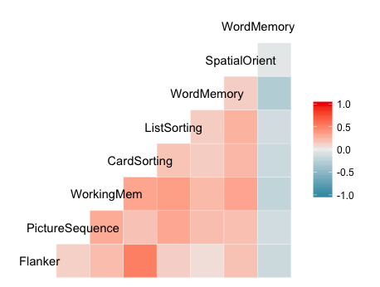

*Figure 1.* Graphical representation of correlation matrix.

*Appendix B*

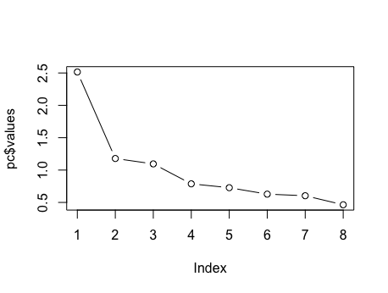

*Figure 2.* Scree plot of eigenvalues of the components to be used in PCA.

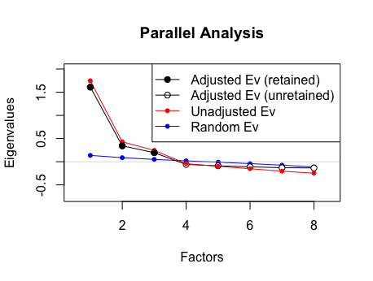

*Figure 3*. Scree plot of component eigenvalues projected atop randomly produced eigenvalues, as produced by parallel analysis.

|  |  |  |  |
| --- | --- | --- | --- |
| Factor | Adjusted Eigenvalue | Unadjusted Eigenvalue | Estimated Bias |
| 1 | 1.61007 | 1.746538 | 0.136468 |
| 2 | 0.34272 | 0.429668 | 0.086947 |
| 3 | 0.194948 | 0.244501 | 0.049553 |
| 4 | -0.059184 | -0.04131 | 0.017871 |
| 5 | -0.088795 | -0.0985 | -0.00971 |
| 6 | -0.109777 | -0.15109 | -0.04131 |
| 7 | -0.129679 | -0.20412 | -0.07444 |
| 8 | -0.133994 | -0.24811 | -0.11412 |

*Table 2*. Table of eigenvalues indicating retention of three factors, as produced by parallel analysis.

*Appendix C*

|  |  |  |  |  |
| --- | --- | --- | --- | --- |
|  | F1 | F2 | F3 | Communality |
| Flanker Inhibition | -0.05 | **0.88** | 0 | 0.76 |
| Picture Sequence | **0.64** | -0.09 | 0.16 | 0.45 |
| N-back | **0.61** | 0.19 | 0.16 | 0.53 |
| Card Sorting | 0.1 | **0.81** | 0.05 | 0.72 |
| List Sorting | **0.76** | -0.07 | -0.01 | 0.55 |
| Word Memory Acc | 0.16 | -0.11 | **0.75** | 0.61 |
| Spatial Orientation | **0.64** | 0.19 | -0.21 | 0.48 |
| Word Memory RT | 0.1 | -0.14 | **-0.81** | 0.68 |

*Table 3*. Factor loadings from 3-factor PCA with oblique rotation. Primary factor loadings are in bold.

|  |  |  |  |  |
| --- | --- | --- | --- | --- |
|  | F1 | F2 | F3 | Communality |
| Flanker Inhibition | 0.06 | **0.87** | 0.05 | 0.76 |
| Picture Sequence | **0.64** | -0.01 | 0.22 | 0.45 |
| N-back | **0.64** | 0.27 | 0.23 | 0.53 |
| Card Sorting | 0.21 | **0.82** | 0.11 | 0.72 |
| List Sorting | **0.74** | 0.01 | 0.06 | 0.55 |
| Word Memory Acc | 0.22 | -0.03 | **0.75** | 0.61 |
| Spatial Orientation | **0.64** | 0.24 | -0.13 | 0.48 |
| Word Memory RT | 0.01 | -0.19 | **-0.8** | 0.68 |

*Table 4*. Factor loadings from 3-factor PCA with orthogonal rotation. Primary factor loadings are in bold.

*Appendix D*

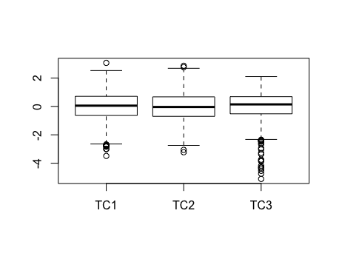

*Figure 4*. Boxplot of factor loadings for the participants with outliers (defined as beyond 3rd or 1st quartile +/-1.5*IQR) indicated by circles.

*Appendix E*

|  |  |  |  |
| --- | --- | --- | --- |
|  | Factor1 | Factor2 | Factor3 |
| Flanker Inhibition | 0.119 | 0.632 |  |
| Picture Sequence | 0.483 |  |  |
| N-back | 0.595 | 0.233 | -0.143 |
| Card Sorting | 0.232 | 0.761 |  |
| List Sorting | 0.569 |  |  |
| Word Memory Acc | 0.28 |  | -0.269 |
| Spatial Orientation | 0.448 | 0.195 |  |
| Word Memory RT | | -0.112 | 0.988 |

*Table 5*. Factor loadings from factor analysis with oblique rotation.